**Calendar-Based Collaboration Proposal**

Blaine Killen Somatic Inc.

**Product/ Service**

People have things on their mind such as tasks, meetings, groups, leisure, and appointments, and when they really break down what it takes to schedule their day, they realize it revolves around individuals, groups, and businesses. Combining all these schedules ends up looking something like this and managing one even of these aspects alone is a complex process. Currently, one must go to several different websites to gain this information, and there is no system to combine these schedules together so you know when you are available while maintaining the user’s privacy.

MeetingSprout’s objective is to make scheduling and organizing within a community a seamless and pleasant experience. We plan to address three types of communities: universities, towns/cities, and organizations. MeetingSprout is a very high-tech and intricate platform. We have identified three principles that will allow us to succeed in solving the real world problems of scheduling and organizing:

1. Information

- We enable users to overcome the information barriers between individuals, groups, and businesses.

2. Privacy

- We allow users to control the privacy of each event and category to fit his or her preferences.

3. Simplicity

- The registration process should allow users to begin scheduling with other users within the first 30 seconds.

- We present free/busy information as shadows to minimize clutter and information overload, a weakness of existing calendar solutions.

Our current market consists of three main types of competitors: organizers, schedulers, and group collaboration tools. Firstly, organizers such as Outlook provide only calendar sharing within a company. Tied down by market placement and identity, these competitors can’t pivot into our idea and design without risking their core brands. These products lack necessary features to help users plan their individual lives. Secondly, schedulers such as Tungle only allow users to merge with other individuals. To make plans, users also need to consider schedules of groups and local businesses with whom they interact. Lastly, group collaboration tools facilitate working with other people. Often, these services are overloaded with features, intimidating many users and complicating the scheduling process.

Filling a void in our market, MeetingSprout combines these three key categories and is the first platform that connects individuals, groups and businesses in a unified place.

**Market Need and User-Based Models**

Our initial market consists of college students and their surrounding community. We will entice students to start using our service by establishing a partnership with the university that will provide students with their class schedule automatically once they log in to our service with their school ID and password. Furthermore, we plan to use our connections and presence on campus in addition to inbound marketing techniques to gain entry into the market. These techniques include the use of social media, such as Facebook and Twitter. Also, we will hire writers to publish engaging content on our blog and other outlets.

We have personally surveyed multiple potential consumers in our market, and through analysis, have found a consistent need to solve the pain. Our interview participants ranged from 18-24 an were primarily college students, proving that our initial market has an actual need for the service. We included two outliers however, both in their thirties, to see if our secondary market were experiencing this same problem, and therefore proving that our service will naturally trickle-up into other markets.

Our system can help users get from the question “what time will our meeting be” to “its at this time” in a faster and more informed way. Users could not get from step a to step b and all the steps in between without first having multiple emails or other forms of communication in between the members. By providing the information of peoples schedule in a communicative and time-based medium, users can go from step a to step b in a matter of seconds after merging calendars together.

The biggest stress to users was when they proposed a time and a member couldn’t do that time, the same time and energy they spent to come up with the initial time was then wasted, and they have to spend that same amount of resources on developing a new time. This created a huge pain for everyone across the survey group, and remained consistent across different majors, studies, ages, and a member’s role in the group.

The biggest step in between that formed an iterative loop until it was settled was the process of proposing and picking a meeting time. A team of three to six members seemed a sweet spot for the amount of team members where a meeting was imperative for all the members to be present. Anything over, the group leader would set a date without respect for the members schedule, and would accept a certain percent of attendees. Below, there seemed to be no trouble in coordinating a time because picking a time between two people did not require multiple schedule comparisons. Projects that had high priority had a higher rate of participation, and stressed more on finding the correct time for everyone to meet.

**System Design**

MeetingSprout is an online social calendar platform that allows users to coordinate their schedule with other users, groups, and businesses while maintaining privacy.

MeetingSprout allows you to:

* View your personal, social, and professional schedule in an easy, simple way
* Merge your calendar with those of your friends, groups, and local businesses
* Send meeting requests in open times
* Establish a reputation for showing up to scheduled events
* Know the reliability of others before scheduling with them
* Create a group with a shared calendar and discussion board
* Set group meetings, due dates, and important events
* Add, remove, and send messages to group members all from one place

• Connect with businesses, schedule appointments, and plan ahead with ease

**Features**

Personal Calendar

Once a user logs in to his or her account, his or her personal calendar appears along with any class schedules, appointments, store discounts, reservations, and notes he or she may have for the week. Along with the personal schedule, the home page also includes any notifications, friend requests, and reputation bar. The reputation bar under the user’s picture increases when he or she shows up to scheduled events and decreases when he or she is late to or does not attend scheduled events.

Privacy

Users can control who can see the details of each event on his or her calendar. One can show all of his events, display only routine events, or hide his entire calendar. Hidden events appear as empty placeholders to indicate the time block as busy.

Merging Calendars

One click allows a user to overlay the available times of other individuals, groups, and businesses on his calendar. This presentation style provides the needed information without creating clutter.

Groups

A user can select two or more friends with whom to form a group, such as a project team, a sports club, a carpool, or even a company. Each group has its own calendar, which can be merged with the calendars of its members. To facilitate efficient collaboration, groups also allow members to assign tasks and schedule group meetings within the same interface.

Businesses

Businesses who have a MeetingSprout account can directly engage their customers. A user who “likes” a specific business, such as a bowling alley, can easily open their calendar and view store hours, promotional offers, and reserved times. This information saves time and prevents needless frustration if a business is closed or fully booked and customers are uninformed. For businesses, the ability to accept online appointments brings quicker decision-making and convenience to its customers. Business calendars, similar to group calendars, can be merged with individuals’ calendars to help customers make decisions and plan their day.

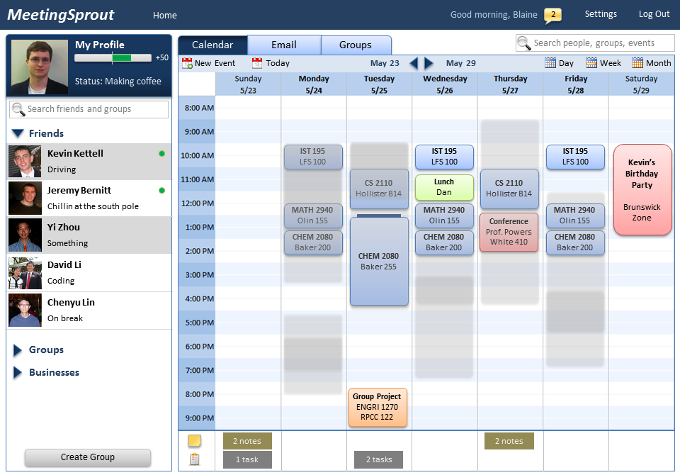

Based in Central New York – one of the densest areas for college campuses – we can use our presence and connections with surrounding colleges to transition into other college communities by copying and pasting our business model. Once we establish the free service to students, we will be able to entice many small businesses in the surrounding college communities to join so they can gain access to our services and to students, who compose the majority of their customers. Furthermore, many small businesses don’t have the time or expertise to create a website to communicate their information and allow users to schedule appointments and engage in transactions directly. Rather, they primarily focus on maintaining core business functions to survive in their market. Thus, small businesses can effectively use our service for these features and gain inbound marketing that will lead to a higher conversion rate from potential to active customers. We also provide small businesses with market research that has never before been available, including statistics of their customers’ availability trends, which become curated after a certain amount of users merge with their calendars, as specified by the business. The business will be able to use that information to advertise, staff appropriately, and offer discounts effectively, saving money and time on the decisions they make every day.

Once we are established in our initial and primary markets, large businesses will be attracted to the large customer base and features we provide. Large businesses use resource-intensive, complex systems to manage appointment scheduling and market research. In addition, customers have to search through multiple pages on the companies’ websites just to find store hours and deals, yet still cannot connect this information to their personal schedules. We provide both scheduling and promotion functions for businesses in an inexpensive but effective way.

Ultimately, with superior brand recognition, MeetingSprout will be well-positioned to target previously untapped client bases such as housewives and retirees. Housewives juggle an ever-growing list of childcare, carpool, and child-friendly activities. They would also like to proactively schedule “me” time with a relaxing manicure appointment or lunch with girlfriends. Similarly, as baby boomers exit the rat-race and look to structure active and meaningful retirements, MeetingSprout enables them access beginner’s yoga, the local library lecture series, and college courses that can be audited for free.

We provide a new way for small and large businesses to promote themselves through inbound marketing, and we plan to monetize by charging small businesses a 40 dollar monthly fee to be present on our site. Large businesses will be charged on a case by case basis, proportional to the size of the corporation and its branches.

Other avenues of revenue include offering a free, ad-supported mobile application with an option to remove ads for 99 cents. This freemium model averages a 2% conversion rate after one year. We also realize the need for desktop applications customized to businesses’ individual needs that allow businesses to maintain their MeetingSprout calendar and online presence, justifying a premium charge. In the future, we plan to implement straight- line advertising, which does not appeal to college students and therefore is not included in our early stages.

**Summary**

What if you could coordinate all the information in your life in one place?MeetingSprout, an online calendar-based community, coordinates individuals, groups, and businesses in a simple and efficient way through curated information.

Individuals need to reference many different sources, ranging from other individuals to businesses, to schedule their day. MeetingSprout brings all needed information into one place and presents them in a clean, relevant fashion in the context of users’ own calendars. As a result, users save time locating the scattered information and avoid the stress of putting it together. Groups can schedule events with the knowledge of its members’ available times. Businesses can promote themselves, inform customers, and accept appointments and transactions, a form of inbound marketing.

Individuals can organize a trip to the gym by merging schedules with their friends to see who is available at what times. They can also merge with the gym’s calendar to find its hours of operation. In addition to scheduling, groups can collaborate using the discussion board and note-sending features. Businesses can access market research derived from their customer base, including the times when most of their customers are available.

The market cap in our primary market, at 2% penetration, is $51.6 million with a growth rate of 1.7% per year. This gives us an estimated revenue of $35,000 for the first year, growing exponentially to an estimated $10,120,000 for year three as we build our user base.